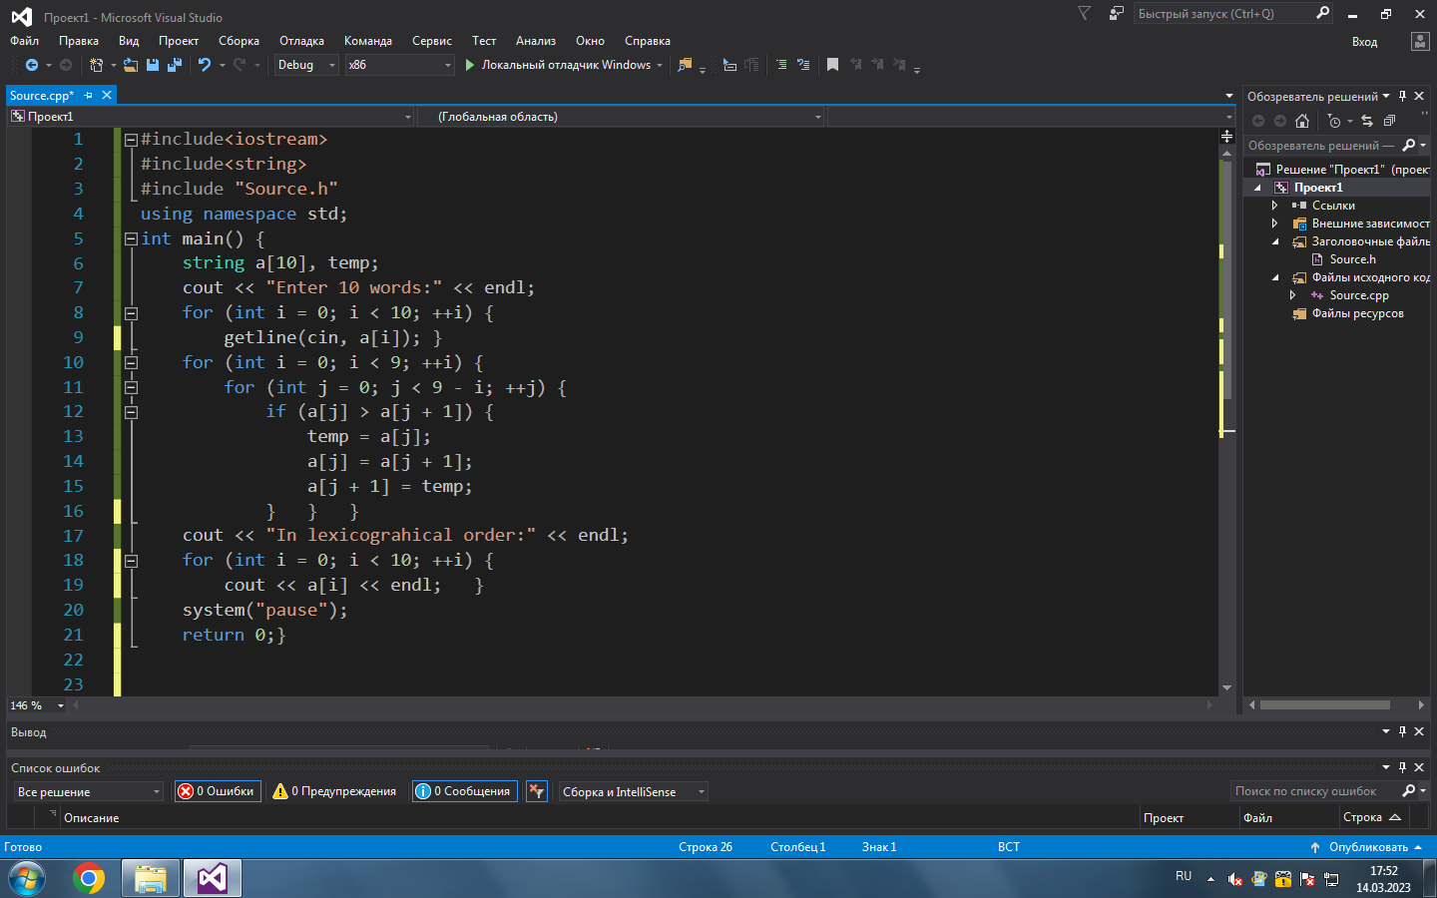

#include<iostream>

#include<string>

#include "Source.h"

using namespace std;

int main() {

string a[10], temp;

cout << "Enter 10 words:" << endl;

for (int i = 0; i < 10; ++i) {

getline(cin, a[i]); }

for (int i = 0; i < 9; ++i) {

for (int j = 0; j < 9 - i; ++j) {

if (a[j] > a[j + 1]) {

temp = a[j];

a[j] = a[j + 1];

a[j + 1] = temp;

} } }

cout << "In lexicograhical order:" << endl;

for (int i = 0; i < 10; ++i) {

cout << a[i] << endl; }

system("pause");

return 0;}

